**Batch Photograph Along With Guide**

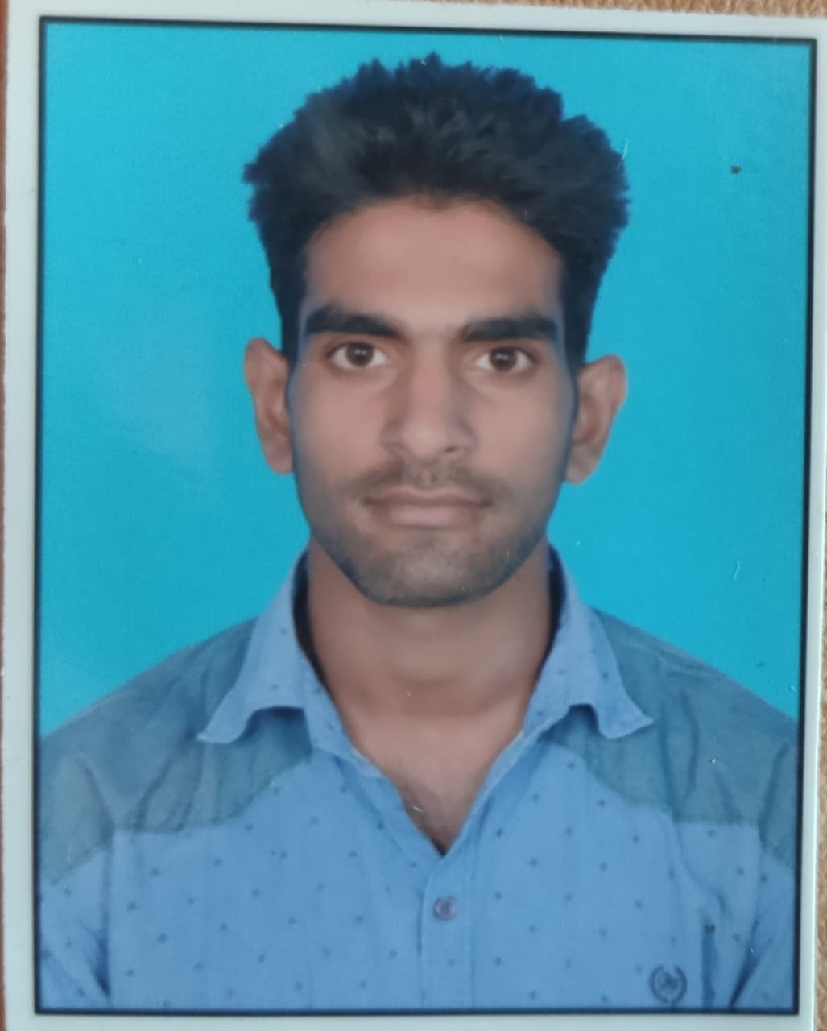 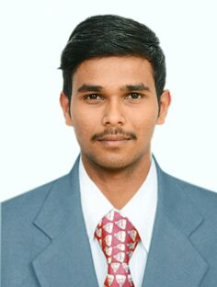 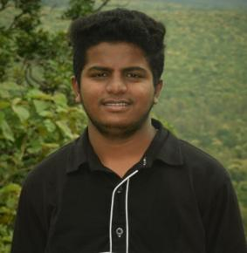 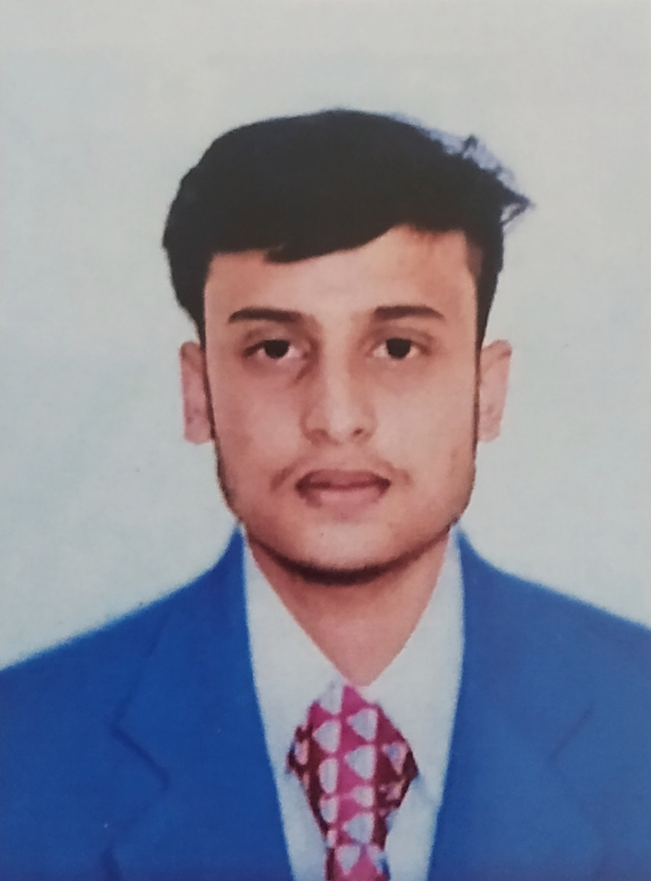

ANISHKUMAR SINGH (17BTREC017), vIJAYAKUMAR S R(17BTLEC008) AKHILESH SHINDHE (17BTLEC002) RAHUL RAO SHINDE (17BTLEC012)